Ex. No. : | 09 | Date : 18/09/2026
Register No. : | 240701629 | Name : Immanuel SA

Building a Blueprint in Zoho Creator

Aim
To build the Maintenance_Lifecycle_Blueprint on the Maintenance_Request form of the RentEase application, so that every repair request moves through a fixed set of stages from Raised to Closed, with the right conditions at each step.

Introduction

Blueprint in Zoho Creator
A blueprint is a visual way to make a record follow a defined process. The process is drawn as stages and transitions. A stage is a state of the record, and a transition is the action that moves the record from one stage to the next. A record can move only through the transitions that the blueprint allows, so steps cannot be skipped. Each transition has three parts: Before, which sets the conditions for the transition to appear; During, which lists the fields that the user must fill; and After, which runs actions or a Deluge script once the transition is done.

The Maintenance Lifecycle in RentEase
A tenant raises a repair request, the manager assigns a vendor, the vendor does the work, the tenant confirms the repair and the request is closed. Repairs that cost more than Rs 5,000 must be approved by the owner before they are completed. Without a blueprint, the status of a request is changed by hand and steps can be missed. The Maintenance_Lifecycle_Blueprint makes this process automatic and consistent.

Objectives of the Study
- To define the stages of the repair process and the transitions between them.
- To make a field mandatory in a transition, such as the vendor in Assign.
- To show a transition only when its condition is true, such as the repair cost limit of Rs 5,000.
- To update the Status of the record with a Deluge script in the After tab of each transition.
- To test the blueprint on a request in Access mode.

Procedure
- Open the RentEase application in Edit mode and click Workflow in the top bar, then open Blueprint.
- Create a new blueprint named Maintenance_Lifecycle_Blueprint on the form Maintenance_Request and select the Status field as the field that holds the stages.
- Add the seven stages: Raised, Assigned, In Progress, Pending Approval, Completed, Tenant Confirmed and Closed.
- Draw the transitions between the stages and name them Assign, Start Work, Send for Approval, Complete, Complete After Approval, Tenant Confirm and Close.
- In the Before tab of Send for Approval, set the criteria Estimated_Cost > 5000. In the Before tab of Complete, set Estimated_Cost <= 5000.
1

Dept. of Computer Science and Engineering | Rajalakshmi Engineering College

- In the During tab of Assign, add Assigned Vendor as a mandatory field.
- In the After tab of every transition, add a Deluge script that sets Status to the new stage.
- Save and activate the blueprint.
- Open the application in Access mode, open a repair request and move it through the stages with the transition buttons.
- Take a screenshot of the blueprint, of a transition and of a request in Access mode.

Detailed Analysis of the Blueprint
Table 1 lists the stages of the Maintenance_Lifecycle_Blueprint.

Stage | Meaning
Raised | The tenant or manager has created the repair request
Assigned | A vendor has been assigned to the request
In Progress | The vendor has started the repair work
Pending Approval | The cost is above Rs 5,000 and the request waits for the owner's approval
Completed | The repair work is finished
Tenant Confirmed | The tenant has confirmed that the repair is done
Closed | The request is closed
Table 1: Stages of the Maintenance_Lifecycle_Blueprint
Table 2 lists the transitions, the condition for each and the work done in its After tab.

No. | Transition | From | To | Condition | After tab
1 | Assign | Raised | Assigned | Assigned Vendor is mandatory | Sets Status to Assigned
2 | Start Work | Assigned | In Progress | None | Sets Status to In Progress
3 | Send for Approval | In Progress | Pending Approval | Shown only if Estimated_Cost > 5000 | Sets Status to Pending Approval
4 | Complete | In Progress | Completed | Shown only if Estimated_Cost <= 5000 | Sets Status to Completed
5 | Complete After Approval | Pending Approval | Completed | None | Sets Status to Completed
6 | Tenant Confirm | Completed | Tenant Confirmed | None | Sets Status to Tenant Confirmed
7 | Close | Tenant Confirmed | Closed | None | Sets Status to Closed
Table 2: Transitions of the Maintenance_Lifecycle_Blueprint

2 Dept. of Computer Science and Engineering | Rajalakshmi Engineering College

Table 3 explains the three parts of a transition and how each is used in this blueprint.

Part | Purpose | Use in RentEase
Before | Sets the criteria that decide when the transition is shown | Repair cost limit of Rs 5,000 for Send for Approval and Complete
During | Lists the fields that the user must fill to do the transition | Assigned Vendor is mandatory in Assign
After | Runs actions or a Deluge script after the transition is done | Script that sets the Status of the request
Table 3: Parts of a blueprint transition
The two conditions on cost send a request through exactly one path after In Progress. A repair of Rs 5,000 or less goes directly to Completed, and a more expensive repair goes to Pending Approval and then to Completed after approval.

Output
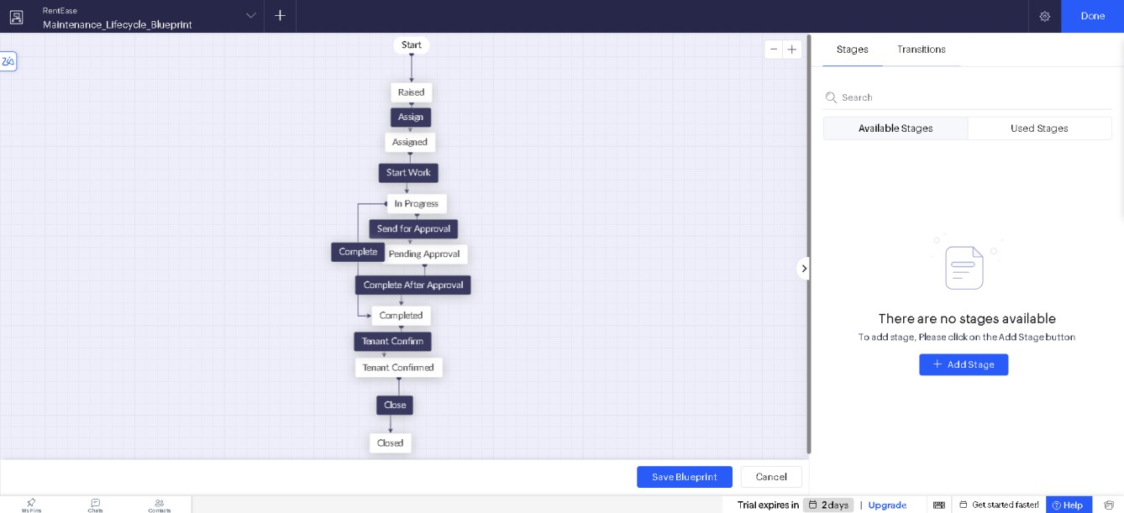
Figure 1: Maintenance_Lifecycle_Blueprint in the editor
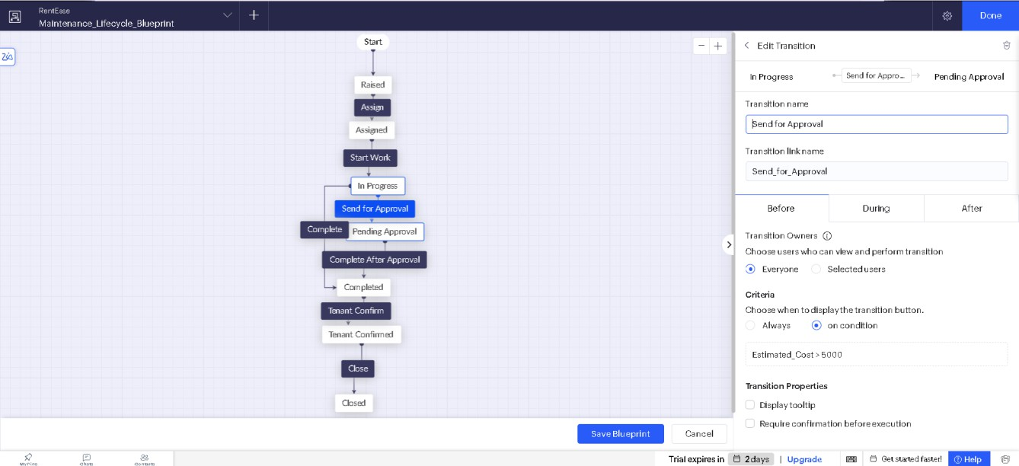

3 Dept. of Computer Science and Engineering | Rajalakshmi Engineering College

Figure 2: Transition settings with the cost condition and the After script
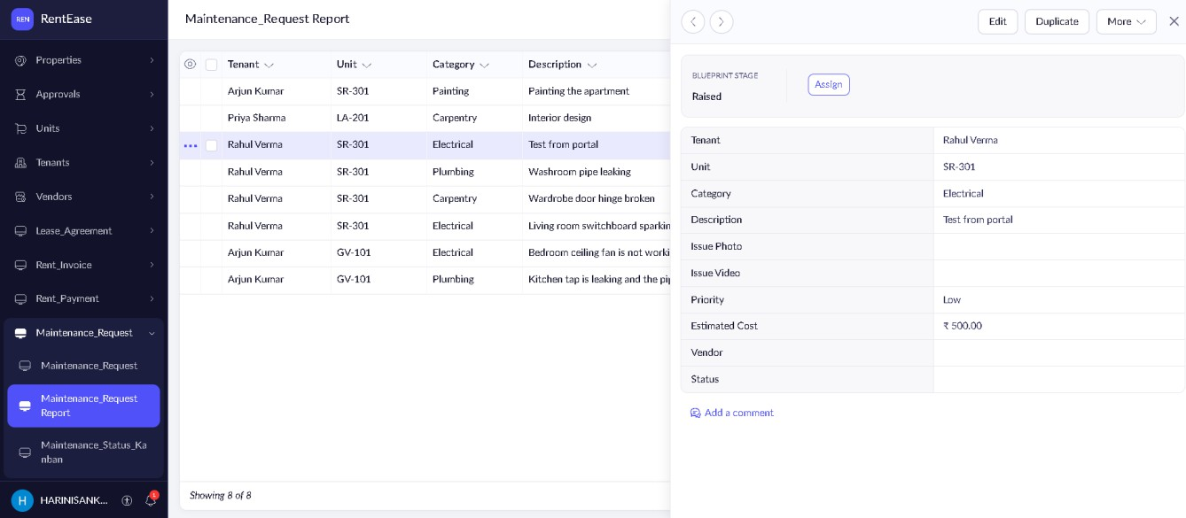
Figure 3: Maintenance request moving through the blueprint

Result
The Maintenance_Lifecycle_Blueprint was built on the Maintenance_Request form and tested in Access mode. A repair request now moves through the stages Raised, Assigned, In Progress, Pending Approval, Completed, Tenant Confirmed and Closed. A vendor must be assigned before work starts, repairs above Rs 5,000 are sent for approval, cheaper repairs are completed directly, and the Status is updated automatically at every step.
4

Dept. of Computer Science and Engineering | Rajalakshmi Engineering College

